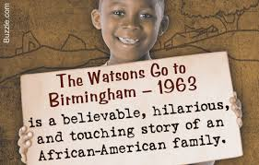
The Watsons Go to Birmingham – 1963
Chapter Reflection
Use RACE!
Chapter 11: Bobo Brazil Meets the Sheik
Research: Who is Bobo Brazil and the Sheik? Why is this the title of chapter 11?
___________________________________________________________________________________________________________________________________________________________________________________________________________________________________________________________________________________________________________________________________________________________________
Explain why both Kenny and Momma are disappointed soon after arriving at Grandma Sands.
___________________________________________________________________________________________________________________________________________________________________________________________________________________________________________________________________________________________________________________________________________________________________
Describe Grandma Sands. Is she anything like Kenny was expecting her to be? Explain your answer.
____________________________________________________________________________________________________________________________________________________________________________________________________________________________________________________________________________________________

